MINISTRY OF EDUCATION AND SCIENCE OF UKRAINE

NATIONAL TECHNICAL UNIVERSITY

«KHARKIV POLYTECHNIC INSTITUTE»

Department of Software Engineering and Management Information Technologies

Report from lab № 5

discipline «Fundamentals of python»

Executed by: Student of group 1.КН.201.8e1

CHUKWU IRELE AMORIN

Checked by: Senior lecturer

Kharkiv

2019

***Laboratory work 5***

***String***

*1.“Making slices”*

Given a string.

Print the third character of this line first.

In the second line print the penultimate character of this line.

In the third line print the first five characters of this line.

In the fourth line print the entire line except the last two characters.

In the fifth line, print all characters with even indices (assuming that indexing starts at 0, so characters are displayed starting from the first).

In the sixth line, print all characters with odd indices, that is, starting with the second character of the string.

In the seventh line, print all the characters in the reverse order.

In the eighth line, print all the characters of the line through one in the reverse order, starting from the last.

In the ninth line print the length of this line.

*2. "Word Count"*

Given a string consisting of words separated by spaces. Determine how many words are in it. Use the count method to solve the problem.

*3. "Two halves"*

Given a string. Cut it into two equal parts (if the length of the string is even, and if the length of the string is odd, then the length of the first part should be one character longer). Rearrange these two parts, write the result in a new line and display it.

When solving this problem, do not use the if statement.

*4. "Rearrange two words"*

Given a string consisting of exactly two words, separated by a space. Swap these words in places. Write the result in a string and print the resulting string.

When solving this problem, do not use loops and if statements.

*5. "The first and last occurrences"*

Given a string. If the letter *f* occurs only once in this line, print its index. If it occurs two or more times, print the index of its first and last appearance. If the letter *f* does not appear on this line, do not print anything.

When solving this problem, do not use cycles.

*6. "The second entry"*

Given a string. Find in this line the second occurrence of the letter *f*, and print the index of this occurrence. If the letter *f* appears in this line only once, output the number -1, and if it does not occur even once, print the number -2.

*7. "Removing a fragment"*

Given a string in which the letter *h* occurs at least twice. Remove from this line the first and last occurrence of the letter *h*, as well as all characters in between.

*8. “Inversion of the fragment”*

Given a string in which the letter *h* occurs at least twice. Expand the character sequence between the first and last occurrence of the letter *h* in the opposite order.

*9. "Substring replacement"*

Given a string. Replace in this line all the digits 1 with the word one.

*10. "Substring replacement"*

Given a string. Replace in this line all the digits 1 with the word one.

*11. "Delete character"*

Given a string. Remove all @ characters from this line.

*12. “Substitution inside a fragment”*

Given a string. Replace in this line all occurrences of the letter *h* with the letter *H*, except for the first and last occurrence.

*13. "Delete every third character"*

Given a string. Remove from it all the characters whose indices are divisible by 3.

Solution:

#1

def slices():

    string1 ="Print the third character of this first"

    string2 ="In the second line print the penultimate character of this line"

    string3 ="In the third line print the first five characters of this line."

    string4 ="In the fourth line print the entire line except the last two characters."

    string5 ="In the fifth line , print all characters with even indices."

    string6 ="In the sixth line ,print all the characters with odd indices, that is , starting with second character of the string."

    string7 ="In the seventh line , print all the characters in the reverse order."

    string8 ="In the eighth line , print all the characters of the line through one in the reverse order , strating from the last"

    string9 ="In the ninth line print the lenght of this line"

    print(string1[2])

    print(string2[-2])

    print(string3[:5])

    print(string4[:-2])

    print(string5[::2])

    print(string6[1::2])

    print(string7[::-1])

    #result = [do_something_with(item) for item in item_list]

    print(string8 = " ".join([ _[::-1] for _ in string8.split()]))

    #print(string8[:-len(string8)-1:-1])

    print(len(string9))

#2

def wordCount():

    string1 = input("enter the line : ")

    print(string1.count(" ")+1)

    #string1.count()

#3

def halves():

    word = input("please enter the word : ")

    l = int(len(word))

    while l % 2 == 0 :

        l /= 2

        print( word[:int(l) :])

        print(word[int(l)::])

        break

    while l % 2 != 0 :

        l /= 2

        print( word[:int(l)+1 :])

        print( word[int(l)+1::])

        break

#4

def rearrange():

    word = input("enter the words : ")

    words = word.split()

    word = words[1] + " " + words[0]

    print(word)

#5

def occurance():

    word = input("enter string : ")

    coun  = word.count('f')

    if coun == 1:

        print(" f found in index : " ,word.find('f'))

    elif coun > 1:

        print("f found multiple times ")

        print("first f found in index : ",word.find('f'))

        print("last f found in index" ,word.rfind("f"))

#6

def secondf ():

    word = input("enter string : ")

    coun  = word.count('f')

    if coun == 1:

        print(-1)

    elif coun > 1:

        print("second f found in index : ", word.find("f",word.find("f")+1,))

    else:

        print(-2)

#7

def frag():

    word = input("enter the word : ")

    print( word.replace( word[ word.find('h')  : word.rfind('h') +1:],""))

#8

def inversion():

    word = input("enter the word : ")

    print(word[ word.find('h')+1  : word.rfind('h') :][::-1])

#9

def substring():

    word = input("enter the word : ")

    print(word.replace('1','one'))

#10

def substring1():

    word = input("enter the word : ")

    print(word.replace('1','one'))

#11

def delete():

    word = input("enter the word : ")

    word = word.replace('@',"")

    print(word)

#12

def subfarg():

    word = input("enter the word : ")

    #print(word[ word.find('h')+1  : word.rfind('h') :].replace('h','H'))

    print(word[:word.find('h')+1 :] + word[ word.find('h')+1  : word.rfind('h') :].replace('h','H') + word[word.rfind('h')::])

#13

def third():

    word = input("enter the word : ")

    for _ in word[::3]:

        if word.find(_) >= 3:

            word = word[:word.find(_)] +  word[word.find(_)+1:]

    print(word)

if __name__ == "__main__":

    third()

No1:

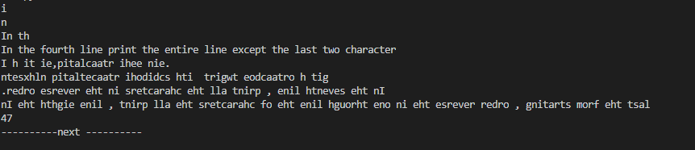

No2:

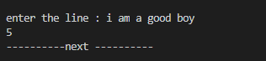

No3:

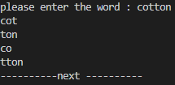

No4:

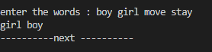

No5:



No6:

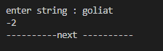

No7:



No8:



No9;



No10;

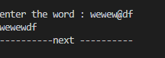

No11:

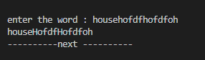

No12:

